Part 1: Hugging Face (The App Store of AI)
Hugging Face is where developers from all over the world share their open-source AI models. But it is not just for code. It is full of interactive demos!
- Create an Account: Go to huggingface.co and click "Sign Up."
- The Search: Once logged in, click on the "Spaces" tab at the top of the page. Spaces are interactive AI apps built by the community.
- The Task: Browse the Spaces and find one that looks fun (try searching for an image generator, a music maker, or a text tool). Play with it!
- Deliverable: Take a screenshot of the result you generated in that Space.

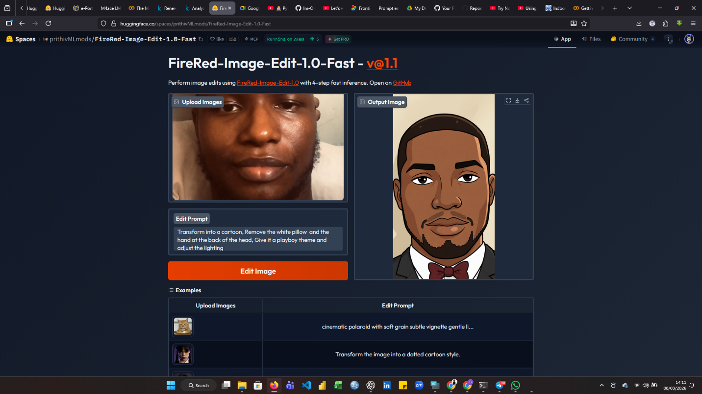

Part 2: Kaggle
AI is nothing without data. AI models learn by studying massive datasets. Kaggle is the world's largest community for data scientists and hosts thousands of free datasets.
- Create an Account: Go to kaggle.com and click "Register."
- The Search: Click on the "Datasets" tab on the left menu. Search for a dataset related to one of your personal hobbies or interests (e.g., "coffee reviews," "soccer stats," "Pokemon data," "climate change").
- The Task: Find a dataset that looks interesting to you.
- Deliverable: Copy the URL link to that dataset. Then, write exactly one sentence explaining why you think having lots of data on this topic would be useful for training an AI.

URL: https://www.kaggle.com/datasets/imtkaggleteam/renewable-energy-1960-2023/code
Having a large dataset on renewable energy trends from 1960–2023 would be useful for training an AI because it allows the model to learn long term patterns in energy production and consumption, helping it make more accurate predictions and insights about future renewable energy development.

Part 3: Google Colab (Your First AI Workspace)
Google Colab is a free workspace in the cloud where you can run Python code without installing anything on your computer. Today, you are going to run a mini AI model in your browser.
- Create an Account: Log in using any standard Google/Gmail account.
- The Search: Click on this link to open the class notebook: NOTEBOOK_LINK
- The Task: * Read the instructions in the notebook.
- Click the "Play" button next to each code cell, going in order from top to bottom. Wait for each one to finish before starting the next.
- When you reach the final code block (Step 3), change the text inside the quotation marks next to my_prompt to a brand-new starting sentence.
- Run the cell one last time to see what the AI writes!
Deliverable: Take a screenshot of your custom prompt and the AI's generated output in Colab.

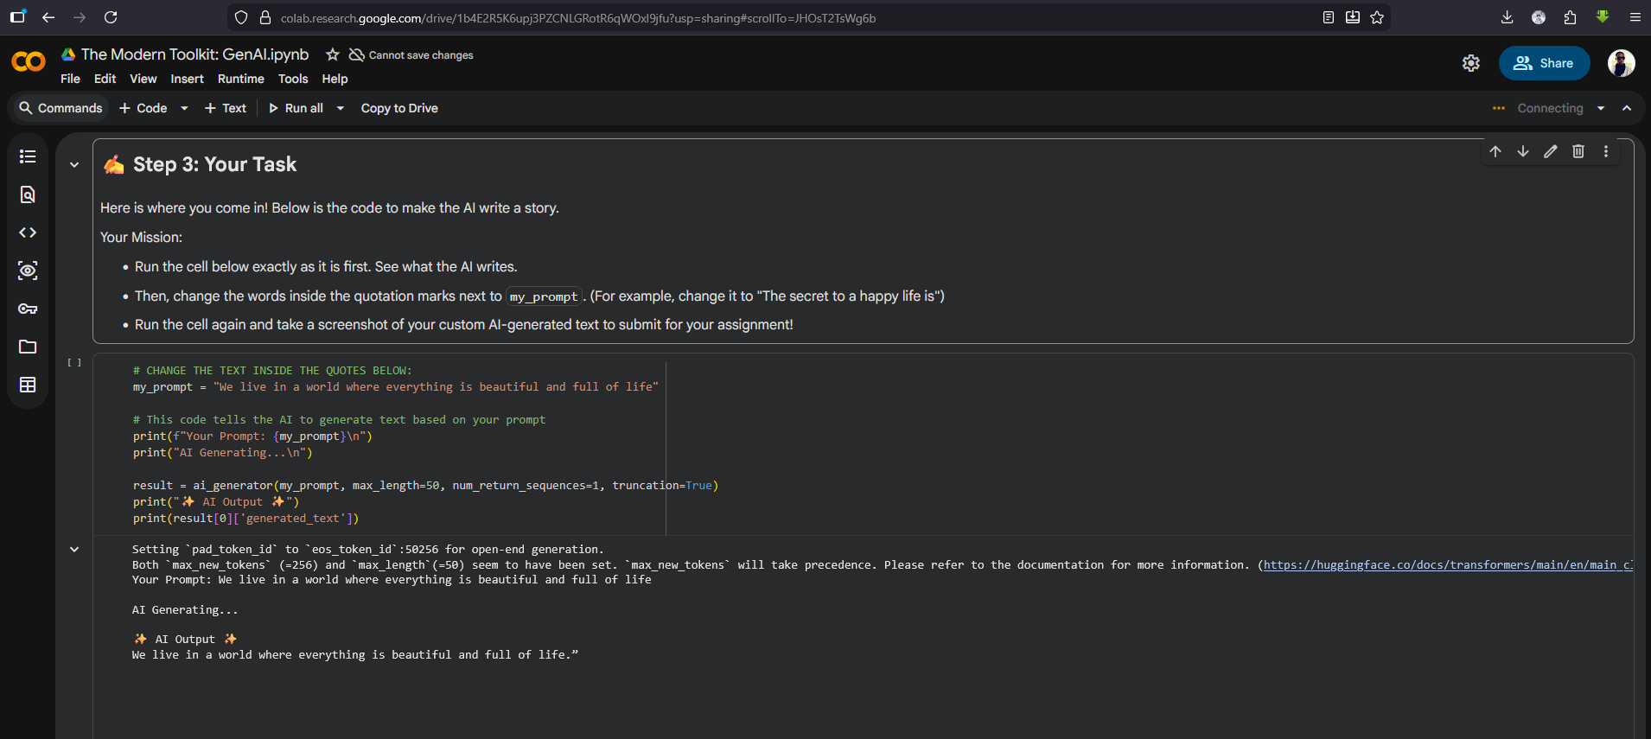

Part 4: GitHub (Your Digital Portfolio)
GitHub is the industry standard for storing, sharing, and collaborating on code. Throughout this bootcamp, this will be your personal showcase. You will upload your projects here so that anyone (including future employers or collaborators) can see what you have built.
- Create an Account: Go to github.com and click "Sign Up." Pick a professional username, as you will likely use this for a long time!
- The Search: Once you are logged in, look for the green "New" button (usually on the left side or under the "+" icon in the top right) to create a new "Repository." A repository is simply a master folder for a specific project.
- The Task: * Name your repository something clear, like "ML-AI-M4ACE". doesn't have to be that name.
- Make sure it is set to "Public" so others can see your work.
- Crucial Step: Check the box that says "Add a README file." This gives your folder a homepage where you can write descriptions of your projects.
- Click the green "Create repository" button.
Deliverable: Copy the URL of your new, public GitHub repository.
https://github.com/Im-Oluman/ML-AI_M4ACE

